TicTacToe Arena — Project Report
Table of Contents
Executive Summary 2
1. Introduction 2
Goals: 2
Assumptions / Unknowns (explicit): 3
2. Business Objectives & Success Metrics 3
3. Functional Requirements 3
4. Non-Functional Requirements 4
5. Technical Architecture 5
High-Level Design (HLD) 5
Tech Stack 5
Data Flow 6
Event & Payload Conventions 6
6. System Components (Detailed) 6
7. Data Model (High-level) 6
8. API Contracts & Endpoints (Representative) 7
9. Distributed Systems & Scalability Strategy 7
Current design strengths 7
Recommendations 7
10. Cybersecurity & Compliance 7
Authentication & Authorization 7
Threat analysis (high level) 8
Data protection & compliance 8
Concrete actionable security items 8
11. Testing Strategy 8
12. Implementation Roadmap (Phased timeline) 9
13. Risk Assessment 9
14. Operational Runbook 10
15. Deployment & CI/CD (Recommendations) 11
16. Cost & Capacity Estimates 11
17. Conclusion 11
18. References 12
19. Glossary 13
20. Appendices 17

Executive Summary
TicTacToe Arena is a low-latency, multiplayer game platform designed as a collection of small, focused Flask microservices and a Vite/React frontend. The system’s runtime design prioritizes responsiveness (Redis-backed runtime state), decoupling (Redis Pub/Sub event bus), and developer ergonomics (per-service Dockerfiles and simple local verifier scripts). Immediate priorities are:
- Fix observed frontend bugs (lobby static names, timer and game-end handling).
- Stabilize event schema contracts and tests.
- Harden authentication flows and Redis availability for production.
Business value: fast turn-based multiplayer with a small operational footprint, enabling rapid experimentation, leaderboards and social features with modest infra costs when scaled prudently.
Key recommendations (top-line):
- Fix front-to-back event contracts and publish an event schema document before cross-service releases.
- Treat Redis as a critical, highly-available component (cluster + replication) and implement write-back reconciliation to the DB.
- Harden cookie-based JWT usage with CSRF protections and short TTLs.

Introduction
TicTacToe Arena is an online, multiplayer tic-tac-toe platform built as a microservices system. Which delivers a production-capable distributed backend and a responsive frontend supporting matchmaking, real-time gameplay, persistent game records, leaderboards, and user profiles.
Key deliverables: functioning Auth, User Profile, Game, Matchmaking, Leaderboard services, a WebSocket gateway, and a Vite/React frontend.

Goals:
  - Low-latency real-time gameplay with per-user Socket.IO rooms.
  - Redis-first runtime state for active games; PostgreSQL for durable metadata.
  - Decoupled services communicating via Redis Pub/Sub.
  - Containerized development/deployment (per-service Dockerfile + docker-compose.yml).

Assumptions / Unknowns (explicit):
  - Production orchestration (Docker Compose + Cloud).
  - Expected peak concurrency (active games/sockets).
  - Exact authServices token storage and claims: assume JWTs with short-lived access + refresh tokens stored in cookies (user notes request cookies).

Business Objectives & Success Metrics
- Objective: Deliver a responsive, engaging multiplayer experience for casual competition.
- Metrics:
  - Player retention (7-day retention)
  - Match completion rate (> 99% under normal load)
  - Median move latency < 200ms
  - System availability 99.9% for gateway and game services
  - ELO ranking accuracy (post-match reconciliation errors < 0.1%)

Functional Requirements
FR-01 - User Authentication:
- Register, login, logout, password reset, email verification.
- JWT-based tokens; access token short-lived; refresh token persisted securely (cookie).
FR-02 - User Profiles:
- CRUD operations for user profile (wins, losses, ELO, display name, avatars, ranks).
- Profile queries: list, search, recent/leaderboard-sorted fetch.
FR-03 - Matchmaking:
- ELO-aware matchmaking with configurable search window and re-check interval.
- Publish match found events to both users.
FR-04 - Game Lifecycle:
- Create game, initialize runtime state in Redis, apply moves atomically, evaluate win/draw/invalid.
- Publish game_update, game_over, and domain GAME_COMPLETED events.
- Persist finished game metadata to Postgres.
FR-05 - Real-Time Transport:
- WebSocket Gateway subscribes to Redis channels and emits to Socket.IO rooms.
- Per-user and per-game room semantics; guarantee ordered delivery per game session.
FR-06 - Leaderboard & Stats:
- Consume domain events to update leaderboards and user statistics.
- Provide leaderboard queries with pagination and season support.
FR-07 - Admin & Observability:
- Health-check endpoints for each service.
- Verifier script “python be/verify_all_services.py” to check local stack.
FR-08 - Security & Tokens:
- Cookie HttpOnly + Secure in production
- CSRF protection for cookie flows and origin checks.

Non-Functional Requirements
NFR-01 – Availability:
- Target: 99.9% service availability for gateway and game services in production.
NFR-02 – Latency:
- End-to-end move propagation latency < 200ms under normal load.
NFR-03 – Scalability:
- Support horizontal scaling: stateless REST services.
- Multiple gateway instances with Redis message queue.
NFR-04 - Consistency & Durability:
- Runtime consistency: Redis as source-of-truth for active games.
- Durability: game completion persisted to PostgreSQL database and use reconcilers for missed writes.
NFR-05 – Security:
- TLS for all external and inter-service communication in production.
- Redis and PostgreSQL restricted to private networks, with authentication and TLS.
NFR-06 - Observability:
- Metrics (Prometheus): socket connections, Redis ops/sec, matchmaking queue length, move apply latency.
- Structured logs & no PII logged.
NFR-07 – Testability:
- Unit tests for game state transitions.
- Integration tests for Pub/Sub flows and WebSocket Gateway.
NFR-08 - Maintainability:
- Clear per-service structure (config.py, extensions.py, routes.py), documented be/.env.example.

Technical Architecture

High-Level Design (HLD)
- Microservices (Flask) each own a bounded context and DB (Postgres) for durable data.
- Redis serves dual roles: runtime state store for gameServices and Pub/Sub message bus for domain and UI events.
- WebSocket Gateway subscribes to Redis channels (game_updates, domain_events, notifications, matchmaking_updates) and forwards messages to clients via Socket.IO rooms.
- Frontend (Vite + React) uses Socket.IO and REST APIs to participate in matchmaking and gameplay.

Tech Stack
Layer | Technology (observed / recommended)
Frontend | Vite, React, Redux Toolkit, TailwindCSS (see fe/README.md)
Backend | Python Flask (per-service under be/services/*)
Real-time bus | Redis Pub/Sub (REDIS_URL env)
Runtime state | Redis (game state under be/services/gameServices/state/)
DB | PostgreSQL (service metadata)
WebSockets | flask_socketio (gateway message_queue=Config.REDIS_URL)
Containerization | Docker + service docker-compose.yml
Background jobs | Optional Celery (env present) or in-service threads (e.g., timeout_manager.py)

Data Flow
- Client requests matchmaking → matchMakingServices finds/creates a match → requests gameServices to create a game.
- gameServices creates DB record, initializes Redis state, and publishes game_start and per-user dashboard_update events to game_updates channel with room fields.
- WebSocket Gateway receives Redis messages and emits Socket.IO events to the appropriate rooms.
- Moves submitted to gameServices (REST /games/<id>/move) are applied in Redis via apply_move. If completed, events game_over and domain GAME_COMPLETED (on domain_events) are published.
- userProfileServices and leaderBoardServices consume domain_events to update stats and leaderboards; frontend receives updates via WebSocket Gateway.

Event & Payload Conventions
- Pub/Sub message JSON schema: { "event": "<name>", "data": {...}, "room": "<room_id>" }.
- Domain events: { "event_type": "<TYPE>", "payload": {...} } on domain_events.

System Components (Detailed)
- Auth Service (be/services/authServices): issues and validates JWTs, supports registration, login, logout, password reset, and email verification. Implementation details for cookie storage should be confirmed and hardened.
- Game Service (be/services/gameServices): primary runtime logic like creates games, initializes Redis state (see state/), applies moves (apply_move) and publishes game_update/game_over events.
- WebSocket Gateway (be/services/websocketGateway): subscribes to Redis channels and emits via Socket.IO; key file main.py contains Redis listener and room-emitting logic.
- Matchmaking Service (be/services/matchMakingServices): ELO-aware matcher; publishes matchmaking_updates.
- Leaderboard Service (be/services/leaderBoardServices): consumes domain_events for leaderboard calculations and persistence.
- User Profile Service (be/services/userProfileServices): Postgres-backed profiles and stat sync logic listening on domain events.

Data Model (High-level)
- Game (Postgres): id (UUID), player1_id, player2_id, status (waiting|active|completed), started_at, finished_at, final_board_state, winner_id, winner_reason, metadata/settings.
- UserProfile (Postgres): user_id (UUID), display_name, first_name, last_name, elo, total_wins, total_losses, win_rate, avatar_url, current_rank, last_season_rank.
- Runtime Redis State (per-game): board array, current_turn, remaining_time, status, winner_id, move_history, settings.

API Contracts & Endpoints (Representative)
Below are the high-level REST endpoints and event contracts observed in the codebase. These should be formalized into an API spec (OpenAPI) as next step.
- Game Service (REST):
  - POST /games - create a new game. Request: { player1_id, player2_id?, settings? } Response: game metadata (DB id).
  - GET /games/<game_id> - read game state (tries Redis first, falls back to DB).
  - POST /games/<game_id>/move - apply a move. Request: { user_id, position } Response: new state or error.
  - GET /games/active/<user_id> - list active games for user.
  - GET /games/recent/<user_id> - list recent completed games for user.
- WebSocket Pub/Sub Events:
  - Channel game_updates: messages { event, data, room } where room is typically game_<game_id> or a user id.
  - Channel domain_events: domain-level messages { event_type, payload } such as GAME_COMPLETED used by stats/leaderboard services.

Distributed Systems & Scalability Strategy

Current design strengths
- Decoupled services via Redis Pub/Sub allow independent scaling and failure isolation.
- Runtime state in Redis supports fast atomic operations and low-latency gameplay.

Recommendations
- Use Redis Cluster for scale and HA. Migrate logical DBs (used in .env.example) to distinct clusters/namespaces if needed.
- Gateway scaling: run multiple gateway instances; rely on Socket.IO message_queue backed by Redis for cross-instance emits.
- Use Redis Lua scripts or MULTI/EXEC to enforce atomic move application and prevent race conditions.
- Add a reconciliation background job that ensures completed games in Redis are persisted to Postgres, idempotently.

Cybersecurity & Compliance

Authentication & Authorization
- Requirement: JWT tokens in cookies (per user notes). Verify current authServices behavior:
  - Ensure Set-Cookie has HttpOnly, Secure (in prod), SameSite=Strict/Lax per front-end cross-site needs.
  - Access tokens vs refresh tokens: use short-lived access token (e.g., 15m) and longer refresh token stored in a secure cookie; refresh via a protected endpoint.
  - For service-to-service auth, use mTLS or signed service tokens (JWT) with limited scopes.

Threat analysis (high level)
- Token theft via XSS: mitigate by storing JWTs in HttpOnly cookies and enforcing CSP and input sanitization in frontend.
- CSRF: if using cookies for auth, enforce CSRF tokens or SameSite cookie policies and verify origin headers at backend.
- Redis exposure: Redis must be protected (no public access), use ACLs, AUTH, and network isolation (VPC). Do not expose Redis to internet.
- Event spoofing: validate domain event schema and sign critical domain events (or add HMAC) to avoid unauthorized publish.
- Injection / SQLi: use ORM parameterized queries (SQLAlchemy used) and validate UUIDs (code uses uuid.UUID()).
- Privilege escalation across services: enforce per-service least privilege in DB and Redis.

Data protection & compliance
- PII in user profiles (names, email): store hashed/limited PII; follow GDPR if applicable (data erasure flows, user consent).
- Transport and at-rest encryption:
  - Transport: TLS for HTTP and WebSocket (wss://), and TLS between services when crossing network boundaries.
  - Redis/Postgres: enable TLS and access controls in production.
- Logging: avoid logging sensitive tokens or PII in plaintext. Sanitize logs.

Concrete actionable security items
- Ensure Set-Cookie includes HttpOnly, Secure (prod), and SameSite attributes.
- Add CSRF middleware or double-submit cookie pattern for cookie-based auth flows.
- Harden Redis (bind to private interface, require AUTH, use ACLs).
- Validate and schema-check all incoming Pub/Sub events before processing.
- Add rate limiting for login endpoints (RATELIMIT_STORAGE_URL present in .env.example).

Testing Strategy
- Unit tests: pure functions (game rule engine, ELO calculations), and small Flask route tests using Flask test client.
- Integration tests: local stack tests that spin up Redis & Postgres (or use testcontainers) and validate the full flow (matchmaking -> game start -> moves -> game_over -> domain event consumption).
- End-to-end tests: scripted browser tests (Playwright) to validate lobby, connection, gameplay, timer behavior and disconnection recovery.
- Load testing: k6 or locust for socket connection ramp-up and Redis op throughput.

Implementation Roadmap (Phased timeline)
Phase 0 - Immediate fixes (1 week):
- Reproduce and fix lobby static-name bug (frontend -> API payload mismatch).
- Inspect fe matching-lobby component; confirm it consumes real match payloads from matchmaking_updates or game_start.
- Fix gameplay timer & end-of-game detection (critical).
- Validate gameServices move evaluation code in state/ and timeout_manager.py.
- Ensure timer value propagates from settings into Redis state; frontend reads remaining_time from game state.
- Ensure apply_move computes completed status and publish_game_update('game_over') is triggered.
- Add integration test harness to simulate two-player match flows using local Redis.
Phase 1 - Stabilize & tests (2–3 weeks):
- Add unit + integration tests for: - Redis state transitions (create_game, apply_move, game completion).
- WebSocket Gateway event routing (subscribe -> emit) using a test Redis instance.
- Harden authentication flows: verify cookie-based JWT, refresh logic, and CSRF protection.
Phase 2 - Observability & reliability (2–3 weeks):
- Add metrics (Prometheus) on socket connections, Redis pubsub throughput, move application latency, matchmaking queue length.
- Add health checks & readiness probes for containers. Expand verify_all_services.py into per-service verify_*.py with endpoint checks.
Phase 3 - Scalability & Productionization (4–8 weeks):
- Prepare deployment manifests (Kubernetes Helm charts) or production-grade Docker Compose with HA patterns.
- Migrate Redis to clustered setup, enable TLS, and configure Redis persistence/backups.
- Add CI/CD pipelines to run tests and build images.

Risk Assessment
Risk | Probability | Impact | Mitigation Strategy
Game state divergence (Redis vs DB) | Medium | High | Treat Redis as source of truth for live games; ensure atomic write-back and reconciler for DB persistence; add idempotency keys.
Event schema mismatch across services | High | Medium-High | Enforce JSON schema validation for pub/sub messages; include version field; update consumers/producers simultaneously.
Auth token theft / CSRF | Medium | High | Use HttpOnly Secure cookies, enforce CSRF tokens or SameSite cookie + origin checks, rotate keys, short token TTLs.
Redis availability (single point) | Medium | High | Use Redis Cluster with replicas, automatic failover, backup/restore plan, and monitoring/alerts.
Improperly scaled WebSocket gateway | Medium | High | Run multiple gateway instances with Redis message_queue and load balancing; stress-test with concurrency targets.
Sensitive data leakage in logs | Low | Medium | Audit logs, redact PII, and ensure logging config excludes tokens.
Race conditions on move application | Medium | High | Use Redis transactions or Lua scripts for atomic move application and state transitions.

Operational Runbook
- Local dev run (per-service):
  - Copy be/.env.example → .env and set REDIS_URL, DATABASE_URL, FRONTEND_URL.
  - Create venv, install requirements: pip install -r requirements.txt inside the service folder.
  - Run: python main.py (services use Config.PORT).
- Quick system check: python be/verify_all_services.py.
- Health checks: add /health and /ready endpoints to each service if missing.
- Backups & restore:
  - Postgres: nightly logical backups + point-in-time recovery plan.
  - Redis: RDB/AOF configuration and periodic snapshot exports to cold storage.
- Incident response:
  - On Redis failure: promote replica or failover; put gateway into degraded mode (read-only) and surface errors to clients.
  - On DB failure: keep runtime games in Redis, queue persistence tasks for later reconciliation.

Deployment & CI/CD (Recommendations)
- CI: run unit tests, linting, and basic integration tests (against ephemeral Redis/Postgres) on PRs.
- CD: build per-service Docker images and tag by commit SHA; promote images through staging → production with database migrations gated by manual approval.
- Orchestration: prefer Kubernetes for production (Helm charts) with readiness/liveness probes. For small-scale deployments, a production-grade Docker Compose with HA proxies is acceptable.

Cost & Capacity Estimates
- To produce accurate costs, provide expected concurrent active games and average session length. Placeholder guidance:
  - Small-scale (<= 500 concurrent games): single Redis primary + replica, 2–3 web/gateway instances, managed Postgres small cluster.
  - Medium (> 500, <= 5k): Redis cluster, multiple gateway replicas, autoscaling policies, Postgres with read replicas.

Conclusion
TicTacToe Arena is architected around a pragmatic set of design choices that prioritize low-latency gameplay, developer productivity, and operational simplicity. The current codebase demonstrates sound patterns — a Redis-first runtime for active games, a decoupled event bus for UI updates and domain events, and modular Flask services that map cleanly to bounded contexts (auth, game, matchmaking, profiles, leaderboards). However, the project is at a stage where operational hardening, formalized event schemas, and tighter frontend-backend contracts are necessary to move from a functional prototype toward a production-grade system.
Immediate priorities are corrective and preventative: (1) fix reproducible frontend bugs (lobby participant display, timer propagation, and deterministic game-end transitions), (2) introduce schema validation and contract tests for pub/sub messages to prevent cross-service regressions, and (3) harden authentication and cookie semantics to reduce security risk. Medium-term efforts should focus on observability (Prometheus metrics, structured logs), Redis high availability (cluster + replicas), and CI/CD pipelines that enforce testing and migration safety.
Execution of these recommendations will reduce incident blast radius, improve player experience (lower latency and fewer mismatch bugs), and provide a clear operational posture for scaling. I recommend a two-week stabilization sprint addressing the top three immediate priorities, followed by a locked release and a second sprint to add contract tests and observability. After these steps, plan a production readiness sprint (Kubernetes manifests, Redis clustering, backups, and runbooks).

References
Kleppmann, M. (2017). Designing Data-Intensive Applications: The Big Ideas Behind Reliable, Scalable, and Maintainable Systems. O'Reilly Media.
Fette, I., & Melnikov, A. (2011). The WebSocket Protocol (RFC 6455). Internet Engineering Task Force. https://datatracker.ietf.org/doc/html/rfc6455
Jones, M., Bradley, J., & Sakimura, N. (2015). JSON Web Token (JWT) (RFC 7519). Internet Engineering Task Force. https://datatracker.ietf.org/doc/html/rfc7519
Fielding, R. T. (2000). Architectural Styles and the Design of Network-based Software Architectures (Doctoral dissertation, University of California, Irvine). https://www.ics.uci.edu/~fielding/pubs/dissertation/top.htm
Elo, A. E. (1978). The Rating of Chessplayers, Past and Present. Arco Publishing.
OWASP Foundation. (2023). Cross-Site Request Forgery (CSRF) Prevention Cheat Sheet. https://cheatsheetseries.owasp.org/cheatsheets/Cross-Site_Request_Forgery_Prevention_Cheat_Sheet.html
Redis Ltd. (2024). Redis Documentation. https://redis.io/docs/
PostgreSQL Global Development Group. (2024). PostgreSQL Documentation. https://www.postgresql.org/docs/
Pallets Projects. (2024). Flask Documentation. https://flask.palletsprojects.com/
Socket.IO. (2024). Socket.IO Documentation. https://socket.io/docs/
Docker, Inc. (2024). Docker Documentation. https://docs.docker.com/
Cloud Native Computing Foundation. (2024). Kubernetes Documentation. https://kubernetes.io/docs/
Prometheus Authors. (2023). Prometheus: Monitoring System and Time Series Database. https://prometheus.io/docs/introduction/overview/
Richardson, C. (2018). Microservices Patterns: With examples in Java. Manning Publications.
Beyer, B., Jones, C., Petoff, J., & Murphy, N. (2016). Site Reliability Engineering: How Google Runs Production Systems. O'Reilly Media.

Glossary
This glossary explains key terms, patterns, and components used in the TicTacToe Arena project. Each entry includes a concise definition, why it matters for this codebase, and where to look for examples in the repository.
Term | Definition | Why it Matters | Example / Location
ELO | A relative skill-rating system that assigns players numeric ratings which change after matches. | Drives matchmaking and ranking; used to find balanced opponents. | See be/.env.example (DEFAULT_ELO_RATING) and matchmaking logic in be/services/matchMakingServices.
Pub/Sub (Publish/Subscribe) | Messaging pattern where publishers emit messages to channels and subscribers receive messages for channels they subscribe to. | Decouples producers and consumers across services; used as the event bus. | Redis Pub/Sub: be/services/websocketGateway/main.py and gameServices/routes.py publish to game_updates and domain_events.
Room (Socket.IO) | Logical grouping in Socket.IO to target events to specific clients (e.g., game_<game_id> or a user id). | Ensures events reach only relevant players or dashboards. | publish_game_update uses room field in messages published by game service.
Redis (runtime state) | In-memory data store used for low-latency state and Pub/Sub channels. | Stores active game boards and supports fast atomic updates. | be/services/gameServices/state/ contains helpers like create_game, apply_move.
Redis Cluster | A production-grade, sharded Redis setup providing high availability and scaling. | Required for HA and scale to avoid Redis single-point-of-failure. | Recommendation in report; production migration step.
WebSocket | Full-duplex communication channel over a single TCP connection (wss/written as WebSocket). | Enables real-time game updates and low-latency interactions. | Implemented with Socket.IO in be/services/websocketGateway.
Socket.IO | A library that provides real-time event-based communication with fallbacks and additional features over raw WebSocket. | Simplifies rooms, reconnection, and message routing for clients and servers. | Gateway uses flask_socketio configured with Redis message_queue in main.py.
JWT (JSON Web Token) | A compact, URL-safe means of representing claims to be transferred between two parties. | Standard token format for authentication/authorization across services. | Auth service and front-end should use JWTs; see be/.env.example and auth service code.
CSRF (Cross-Site Request Forgery) | Attack that forces a user to execute unwanted actions in a web application where they’re authenticated. | Cookie-based auth flows must mitigate CSRF. | Use CSRF tokens or SameSite cookie settings; noted in Security section.
CORS (Cross-Origin Resource Sharing) | Browser mechanism that allows controlled access to resources located outside a given domain. | Frontend origins are whitelisted for Socket and REST calls; misconfiguration blocks clients. | be/services/*/main.py configures CORS using env FRONTEND_URL.
PostgreSQL | Relational database used for durable metadata like finished games and user profiles. | Persistent store for audit, leaderboards, and historical data. | DB models under be/services/*/db/ and migrations folders.
Docker & docker-compose | Containerization and local multi-container orchestration tool. | Reproducible local dev and simplified deployments. | Each service has Dockerfile and many have docker-compose.yml under be/services/*.
Kubernetes | Container orchestration platform for production deployments with autoscaling and HA. | Recommended for production for orchestrating multiple services, auto-healing, and scaling. | Suggested in roadmap; manifests not present yet.
Flask Blueprints | Flask pattern for modularizing routes and handlers into reusable components. | Keeps service code organized and consistent. | routes.py in each service registers a blueprint in main.py.
Domain Event | A semantic event representing a significant business occurrence (e.g., GAME_COMPLETED). | Used to trigger cross-service side-effects like stats updates and leaderboard adjustments. | gameServices publishes GAME_COMPLETED to domain_events channel.
Reconciliation (write-back) | Background process that ensures durable persistence (DB) reflects runtime state (Redis). | Guarantees eventual consistency and handles missed writes during failures. | Recommended pattern in report; implement as background worker or Celery task.
TTL (Time To Live) | Expiration time for ephemeral data (seconds). | Used for move timers, session expiry, and Redis key lifecycle. | be/.env.example contains MOVE_TIME_LIMIT and other TTLs.
Timeout Manager | Background component that enforces time-based rules (e.g., move timeout). | Ensures games progress and handles forfeits/timeouts. | be/services/gameServices/timeout_manager.py.
Atomic Operation | Operation that completes fully or not at all; often implemented using Redis transactions or Lua scripts. | Prevents race conditions when multiple clients attempt conflicting updates. | Use Redis MULTI/EXEC or Lua scripts for apply_move operations.
Lua Script (Redis) | Server-side script executed atomically inside Redis. | Ideal for complex atomic logic (move validation + state update). | Recommended for apply_move to prevent race conditions.
Idempotency | Property that repeating the same operation has the same effect as doing it once. | Important for safe retries of REST calls and background tasks. | Use idempotency keys for move submission and DB writes.
Rate Limiting | Policy to limit requests from a client over time. | Protects endpoints (login, matchmaking) from abuse and brute-force attacks. | Configure using RATELIMIT_STORAGE_URL pointing to Redis (see .env.example).
Observability | Collection of metrics, logs, and traces to understand system behavior. | Essential for debugging latency, errors, and capacity planning. | Add Prometheus metrics + structured logs (recommendation in report).
Contract Test | Tests that validate producers and consumers of events or APIs follow the agreed schema. | Prevents cross-service regressions caused by event/payload changes. | Add JSON schema validation for Pub/Sub messages and contract tests for gateway and services.
Leaderboard | Ranked list of players computed from match outcomes and ELO adjustments. | Primary user-facing metric for competition and retention. | be/services/leaderBoardServices consumes domain_events to update ranks.
Matchmaking | Algorithm and service that pairs players for games based on ELO and configuration. | Core UX: fairness and wait time tradeoffs. | be/services/matchMakingServices and settings in .env.example.

Appendices
Auth Service:
Config.py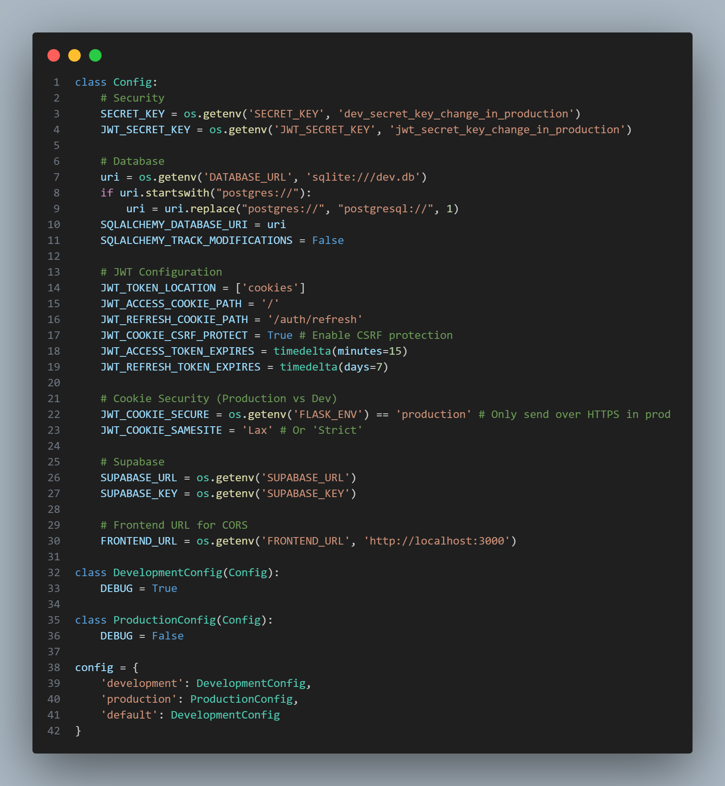
Register Route
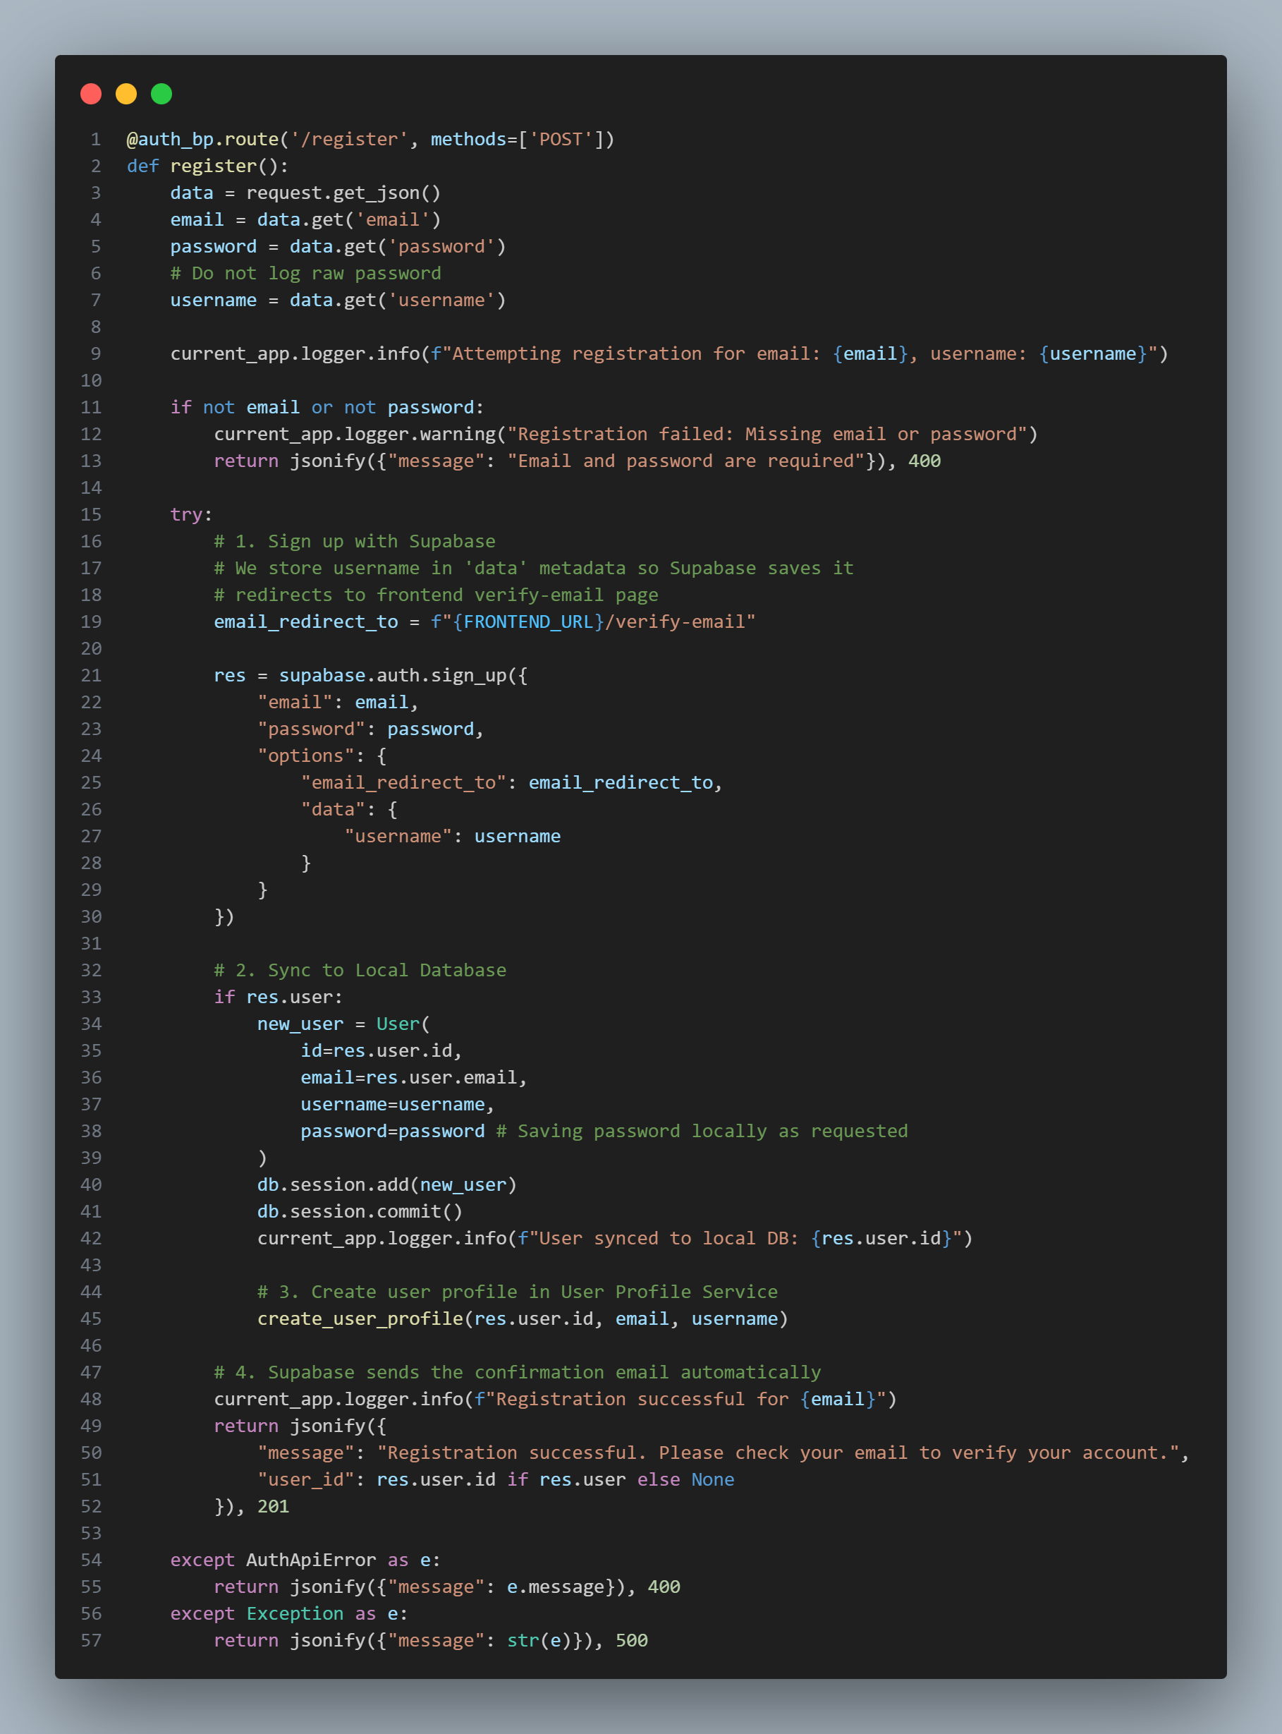
Game Service:
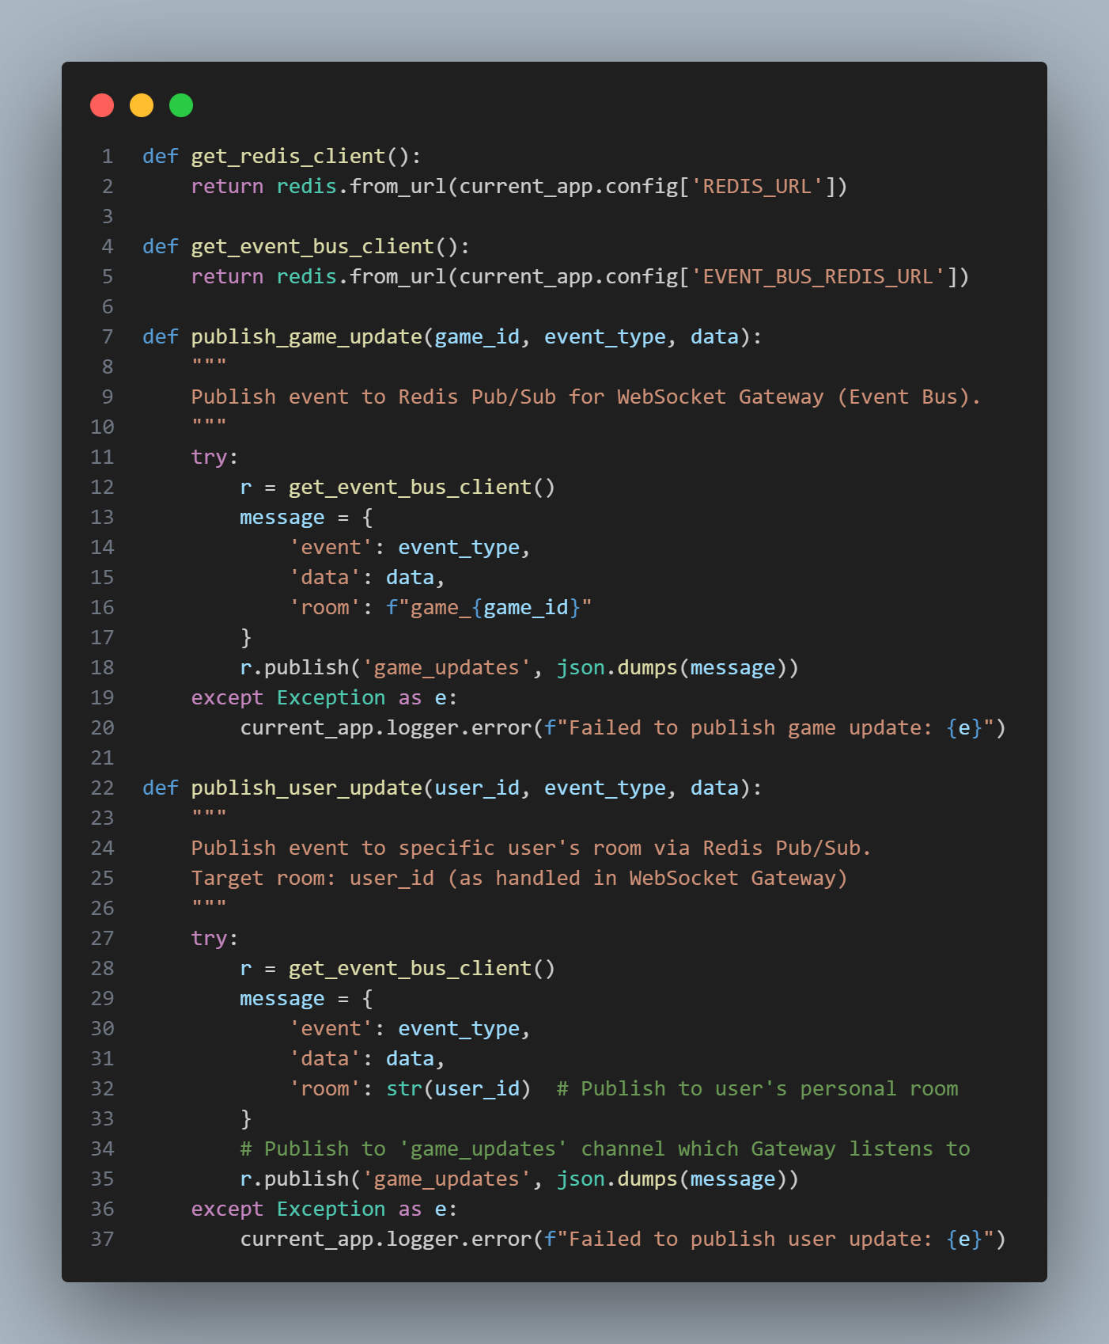
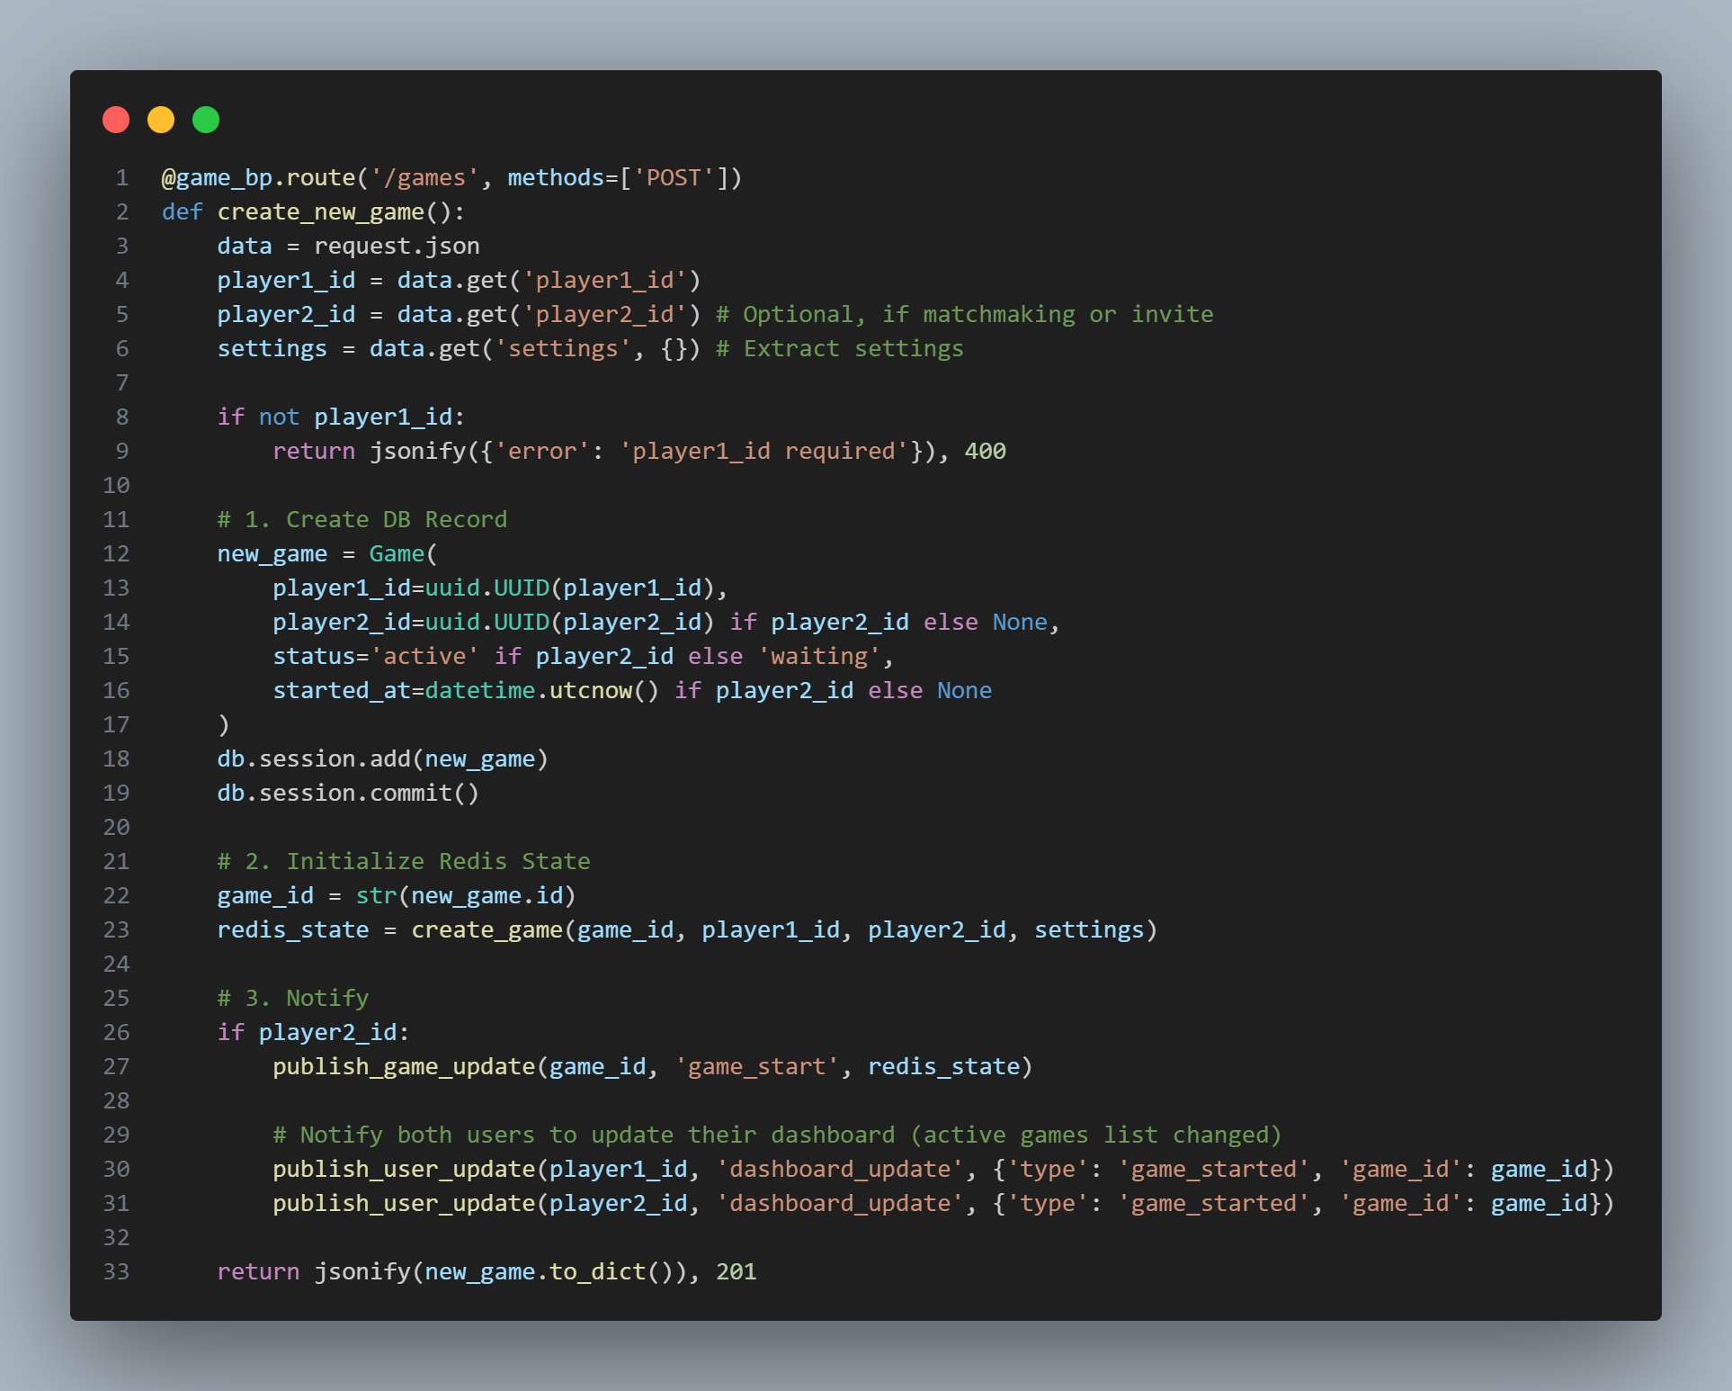
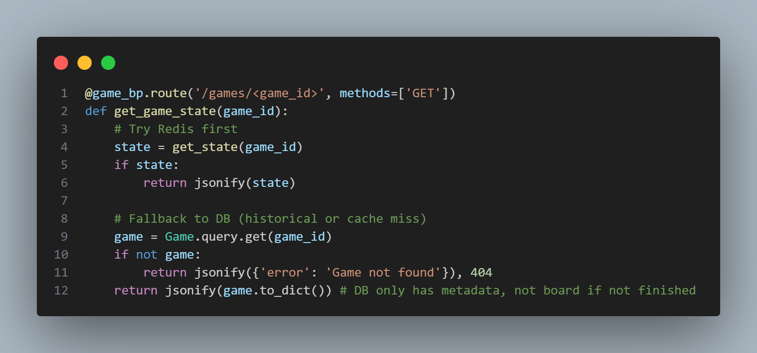
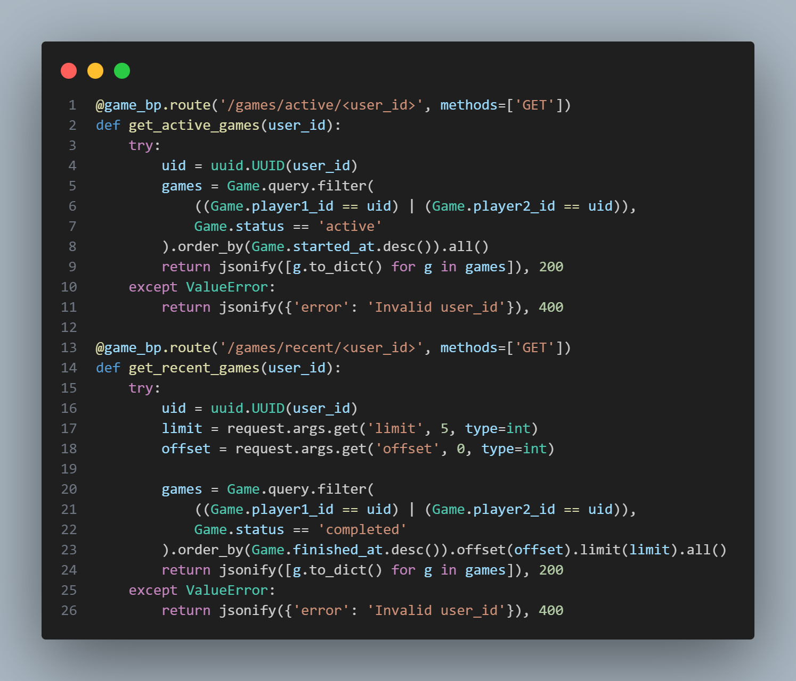
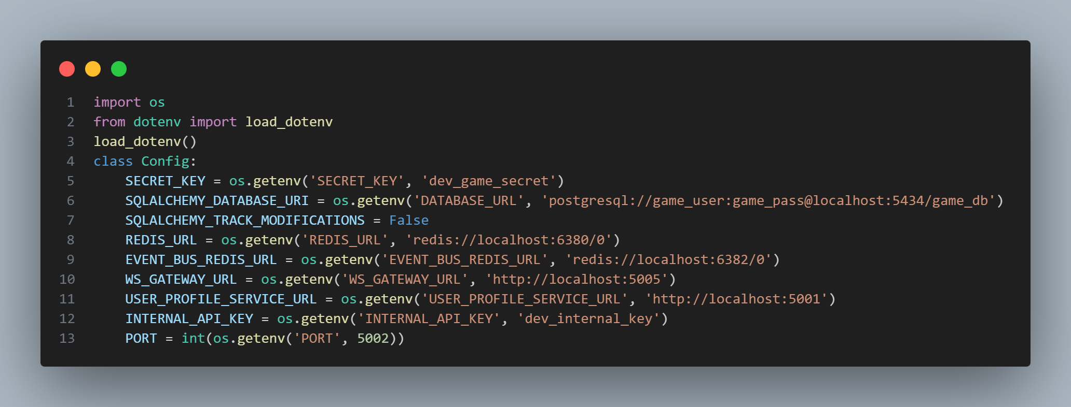
Leaderboard Service:
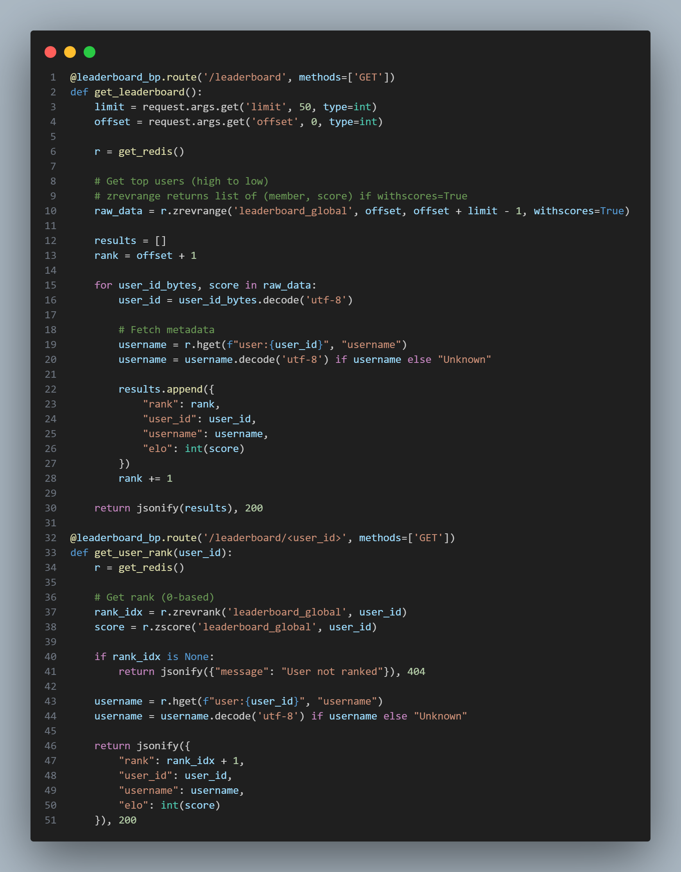
Matchmaking Service: